|  |  |  |
| --- | --- | --- |
| Obraz 9 |  | Obraz 2 |
| LESZNO AERO CLUB | LESZNO AIRFIELD FOUNDATION | AERO CLUB OF POLAND |

**23rd Polish National Gliding Championship in Club Class A**

**9 - 17* MAY 2025,**

**LESZNO, POLAND**

**BULLETIN 1, January 2025**

Dear Friends,

On behalf of Leszno Aeroclub and Leszno Airfield Foundation I am honoured to invite all glider pilots to take part in 15th Polish Gliding Championship in Club A Class. This championship will be held together with Nationwide Gliding Competitions in Club Class A, at Leszno Airfield (EPLS) from 09th to 17th May 2025.

Leszno Airfield is one of the most known sport airfield in Europe, where you can find safe area for long and fast flights (the speed record of 170 km/h on the distance 360 km was set here). The beginning of May is statistically the best period with very good gliding weather, crops in the fields are still low, towing pilots are hungry for flying. What more could gliders pilots want?

Despite the difficult times, including the tragic conflict in Ukraine (which fortunately is more than 700 km away from us and has no impact on the operations at Leszno Airport) we believe that it'll be a great, exciting and safe championship.

Here you can find some important information:

1. **Place and Date:**

The Championships will be held on **09 - 17* May 2025**,at Leszno airfield (EPLS), situated in the Western Poland between two big cities: Poznań and Wrocław and about 300 km west of Warsaw.

The 100 hectares grass airfield has two parallel strips (23- 05) of 920 x 50 m and one (18–36) strip of 880 x 50 m.

* Aerodrome Reference Point: 51°50’06’’N 16°31’19’’E,
* Radio frequency: 122,305 MHz
* Elevation: 94 m. / 308 feet AMSL.

There is a big secured parking area for trailers and gliders, with water and power supply.

1. **Championships schedule:**

|  |  |
| --- | --- |
| Deadline for approval of new GNSS FRs |  |
| Airfield availability for training flights | From 01.05.2025 |
| Online application & registration starts | 15.01.2025 |
| Online application & registration ends | 01.06.2025 |
| On site registration | 09.05.2025 |
| Acceptance checks for gliders | 09.05.2025 |
| Opening ceremony | 09.05.2025 20:00 lt |
| First competitors briefing (obligatory) | 09.05.2025 20:20 lt |
| Contest flying begins | 10.05.2025 |
| Contest flying ends | 17.05.2025 * |
| Closing ceremony and prize giving | 17.05.2025 20:00 lt |

* In case, that after 17.05.2025, one task is missing for contest completion, the reserve day will be held for 18.05.2025. The attempt to hold a third task will be taken on the same day. The final date and time of the official closing ceremony depend on the date of the third task. The regulatory time needed to announce the official results of the last task will be in use..

1. **Organizers:**

- The organizer of the event is the Aero Club of Leszno (AEROKLUB LESZCZYŃSKI).

- All correspondence is to be addressed to the Organization Committee:

AEROKLUB LESZCZYŃSKI

UL. SZYBOWNIKÓW 28

64-100 LESZNO, P O L A N D

- Mobile + 48 602 111 161 +48 517 542 268

- e-mail: <[biuro@aeroklub.leszno.pl](mailto:biuro@aeroklub.leszno.pl)> internet: <[www.aeroklub.leszno.pl](http://www.aeroklub.leszno.pl) >

1. **Championships Staff:**

|  |  |
| --- | --- |
| Championships Director | Mariusz Poźniak |
| Chief Scorer | Marek Uzarowski |
| Task Setter | Mariusz Poźniak |
| Meteo | Elmer Joandi |
| Grid / Launch / Landing | TBD |

1. **Championship classes:**

* 14th Polish Gliding Championship in club class A with handicap index. Max. number of gliders - 40
* Nationwide Gliding Competitions in club class A with handicap index. Max. number of gliders - 40.

1. **Terms of participation:**

**6.1 Regarding the pilot:**

* valid glider pilot license
* valid aero-medical certificate
* valid FAI Sporting License
* valid radio operator's certificate
* Personal medical insurance must be valid for Poland, Germany and Czech Republic is required for all pilots and crews, covering accidents and sickness, including any hospital costs and transport back to the team member’s home country. Pilots in particular should ensure that their insurance will extend to accidents and injuries sustained whilst gliding and in competition.
* minimum 200 hours of command flight time and 5000 km

**6.2 Regarding the glider**

* Airworthiness Review Certificate (ARC)
* Certificate of Airworthiness or Permit to Fly
* Serviceable 8.33 kHz spacing-capable EASA approved VHF radio station & radio license
* Third Party Liability insurance for glider with MTOM:
  + less than 500 kg – minimum 750.000 SDR,
  + from 500 to 1000 kg – minimum 1.500.000 SDR
* Flight Manual
* Gliders in all classes must be equipped with FLARM anti-collision devices.

Notes:

a) at technical inspection, competitors will be required to demonstrate that the FLARM is operational

b) FLARM should remain operational during all flights, in order to improve safety

c) Random checks of function and range may be carried out to ensure that FLARM transmission and reception is satisfactory for adequate collision avoidance.

**6.3 Mandatory additional equipment:**

* audio variometer and FLARM must be fitted and used in all sailplanes.
* all instruments, PDA, GPS navigators etc., must be firmly mounted in the glider in such a way that the pilot’s field of observation is not affected.
* high visibility markings are not required.

1. **Application for participation in the competition**

* Applications will be made online only: <http://www.aeroklub.leszno.pl/index.php/registration/>
* Applications will be accepted until 10April 2023.

1. **Entry fee and towing cost**

Entry fee is for each participating glider covers all operational costs, except aero tows. Entry fee shall be credited to organizer’s bank account by 10April 2023.

Bank account details (EUR account):

EUR **Bank Name:** SANTANDER Bank

**Bank Account Number:** IBAN: PL68109012550000000136146391

SWIFT: WBKPPLPP

Reference (Transfer title): „Leszno Cup, Name of Pilot”

Entry fees are to be paid by the bank transfer to the above give account.

* 23rd Polish Gliding Championship in Club class A - entry fee of 210 Euro

Towing fees are to be paid by Credit Cards or in cash.

* Towing for 600 m AGL - 45 EURO /200 PLN (Polish Złoty) each class. Prepayment for 3 aero towings must be completed at the latest on the last day of registration (04.05.2025)
* Landing fee for self-launching gliders is 10 EURO / 45 PLN (Polish Złoty)
* All competitors who will need an invoice for the entry fee and towing costs, are obliged to provide, as the title of the bank transfer, the tax ID number of the institution or a company to which the invoice is to be issued

1. **Rules**

The Rules and Local Procedures will be publish on the web site <[www.aeroklub.leszno.pl](http://www.aeroklub.leszno.pl)>

1. **Participant skills requirements (only for 14th Polish Gliding Championship in club class A)**

Pilot must hold a Sporting License issued by NAC and obtain not less than 750 points in the IGC Ranking List in the year 2024.

1. **Competition Area and Airspace**

The competition area and airspace will be published on the Aeroklub Leszczyński website <[www.aeroklub.leszno.pl](http://www.aeroklub.leszno.pl)>

The competition area covers mainly flat regions of western Poland and eastern Germany and partly mountainous area in northern Czech Republic. In the mountainous area the summits are 500 m to 1600 m AMSL.

Be sure that competitor, crew and the glider are permitted to enter Poland, Germany and Czech Republic Airspace.

1. **Other conditions**

The organizer provides:

* Turn points and airspace data (co-ordinates of the departure, turn and control points and restricted areas) in the required formats. Loading files into their flight recorders or other navigational equipment remains the exclusive responsibility of the competitors .
* Airfield maintenance and ground staff
* Meteo service
* Aero towing
* Self Briefing file
* Parking for gliders, trailers and cars
* Water filling facilities
* Scoring service, trophies, medals, diplomas

1. **Accommodation**

On site and nearby Leszno Airfield you can find wide range of accommodation (among others):

* Apartments (at the airfield): [www.booking.com/hotel/pl/apartamenty-lotnisko-leszno.pl.html](http://www.booking.com/hotel/pl/apartamenty-lotnisko-leszno.pl.html)
* “Baraczek” (rooms at the bungalow) : <https://www.booking.com/hotel/pl/baraczek-lotnisko-leszno.pl.html>
* Hotels (100 -200 meters from the airfield): [www.achtotu.com.pl](http://www.achtotu.com.pl), [www.mojaleszno.pl](http://www.mojaleszno.pl)
* Hotel Akwawit (3 km from the airfield): https://www.hotelakwawit.pl/
* Rooms / agrotourism: „Agroturystyka Strzyżewice” - <https://www.nocowanie.pl/noclegi/leszno_6/agroturystyka/185665/>
* Campsite (at the airfield) +48 601 484 604:

- the tent: 6 EURO (25 PLN) / day + 6 EURO (25 PLN) / person / day

- CAMPER 14 EURO (60 PLN) / day + 6 EURO (25 PLN) / person / day

- Camping trailer 12 EURO (50 PLN) / day + 6 EURO (25 PLN) / person / day

Mariusz Poźniak

CHAMPIONSHIPS DIRECTOR

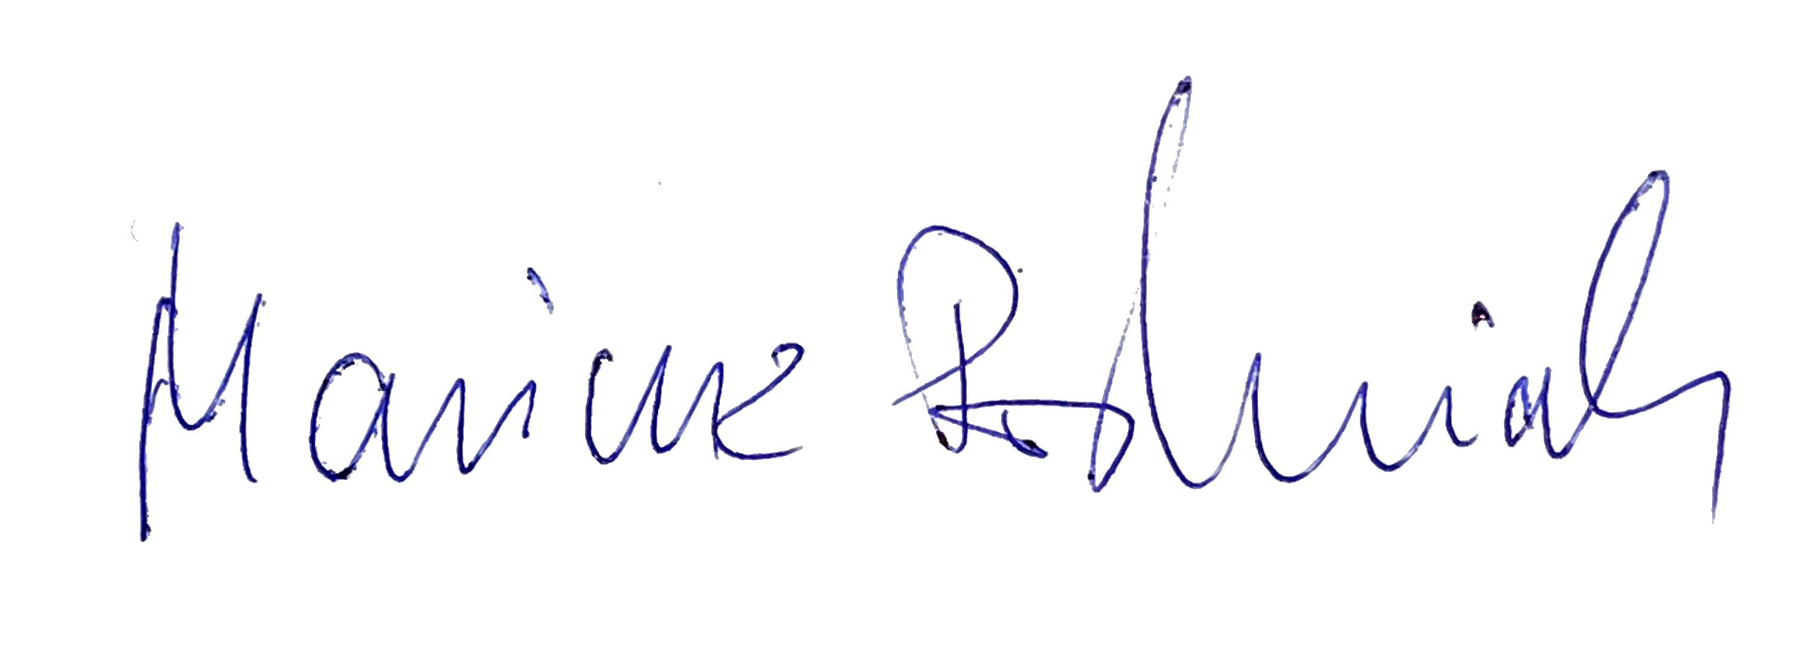

-END-